I.

1. A relation is in the 2NF if it’s in 1NF and there is no non-prime attribute that is not fully functional dependent on every key from the relation.

1. • for every group of max. m blocks in R:

• read the group of blocks from R into main memory; let M1 be the set of records in these blocks

• for every group of max. n blocks in S:

• read the group of blocks from S into main memory; let M2 be the set of records in these blocks • for every r ∈ M1:

• for every s ∈ M2: add (r, s) to the result

II.

1.

a.

b.

DROP TABLE OrderSubcategory

DROP TABLE Orders

DROP TABLE Customers

DROP TABLE Types

DROP TABLE Instruments

DROP TABLE Subcategory

DROP TABLE Category

CREATE TABLE Category(

CID INT PRIMARY KEY,

CName VARCHAR(50),

CDesc VARCHAR(50))

CREATE TABLE Subcategory(

SCID INT PRIMARY KEY,

SCName VARCHAR(50),

CID INT REFERENCES Category(CID))

CREATE TABLE Instruments(

IID INT PRIMARY KEY,

ISN INT,

IManDate DATE,

IColor VARCHAR(50),

IPrice REAL,

SCID INT REFERENCES Subcategory(SCID))

CREATE TABLE Types(

TID INT PRIMARY KEY,

TName VARCHAR(50))

CREATE TABLE Customers(

CSID INT PRIMARY KEY,

CSName VARCHAR(50),

TID INT REFERENCES Types(TID))

CREATE TABLE Orders(

OID INT PRIMARY KEY,

CSID INT REFERENCES Customers(CSID),

PlaceDate DATE,

DueDate DATE,

IsOnline BIT

)

CREATE TABLE OrderSubcategory(

OSID INT PRIMARY KEY,

OID INT REFERENCES Orders(OID),

SCID INT REFERENCES Subcategory(SCID),

Nr INT CHECK (NR > 0),

Color VARCHAR(50))

2.

a.

SELECT NrInstr.CSID, NrInstr.TotNrInstr FROM

(SELECT Customers.CSID

FROM Customers

INNER JOIN

Types ON Customers.TID = Types.TID

WHERE Types.TName = 'Orchestra') Orch

INNER JOIN

(SELECT Customers.CSID

FROM Customers

INNER JOIN Orders ON Orders.CSID = Customers.CSID

WHERE Orders.OID IN

(SELECT Orders.OID FROM Orders

INNER JOIN

OrderSubcategory ON OrderSubcategory.OID = Orders.OID

INNER JOIN

Subcategory ON Subcategory.SCID = OrderSubcategory.SCID

WHERE Subcategory.SCName = 'Violin')

GROUP BY Customers.CSID

HAVING COUNT(\*) >= 3) Min3Violin

ON Orch.CSID = Min3Violin.CSID

INNER JOIN

(SELECT Customers.CSID, SUM(OrderSubcategory.Nr) TotNrInstr

FROM Customers

INNER JOIN

Orders ON Orders.CSID = Customers.CSID

INNER JOIN

OrderSubcategory ON OrderSubcategory.OID = Orders.OID

GROUP BY Customers.CSID) NrInstr

ON Min3Violin.CSID = NrInstr.CSID

b.

SELECT Subcategory.SCName, Instruments.ISN, Instruments.IPrice

FROM Instruments

INNER JOIN

Subcategory ON Subcategory.SCID = Instruments.SCID

INNER JOIN

Category ON Category.CID = Subcategory.CID

WHERE Category.CName = 'String' AND Instruments.IPrice < 2000

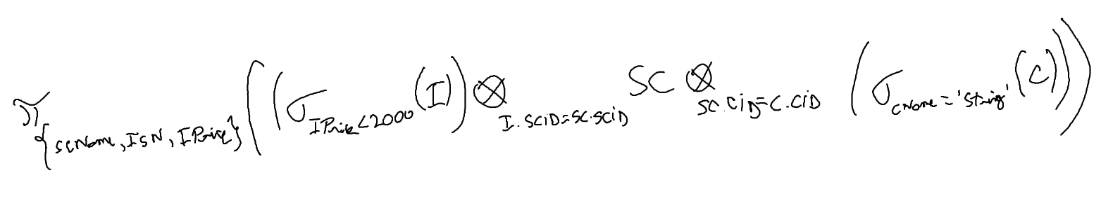

IV.

